AWS Transform

Component Standard

Version | : | 0.01 First Draft
Date | : | 2026-01-19
Author | :

Version control
Version | Date | Author/updated by | Comments
0.01 | 2026-01-21 | Mohamed Kerbachi | First Draft

Note:
Dates in ISO format: YYYY-MM-DD
Versions: 0.XX Pre-release, n.XX Release, n.XX.xx draft releases of version under version control
Contents
Overview 8
Drivers and Motivation 8
Business Value 8
Considerations 10
Security Considerations 10
Cost Optimization 10
Operational Excellence 10
Reliability 10
Performance Efficiency 10
Sustainability 10
Functionality / How it Works 11
Architectural Attributes 12
Interfaces 12
Redundancy, Availability & Reliability 12
Scale, Elasticity & Capacity 12
Cost, Business & Support Models 12
User Access & Roles 13
Federated Roles 13
Access Control Policies 13
Restrictions 13
Permitted Regions 13
Use Cases 14
Use Case One 14
Use Case Two 14
Data & Governance 15
Data Classification 15
Guardrails 15
Guardrail Name 15
Guardrail Name 15
Guardrail Name 15
Capabilities and Product Comparison 16
Capability Table 16
Component Comparison 16
Exceptions 17
Links to other architectural documents used at Aegon 18
Related Component Standards 18
Architectural Patterns 18
Reference Architecture 18
Solution Architectures 18

Distribution and Contacts
Use confluence link to find contacts for the below section. Delete red text when done.
Link: ISO, DPO and Architects - GTS Architecture Solution Design - Global IT Confluence Production (aegon.com)
This document and future updates to be shared with the business representatives shown below.
Business Contacts and Information
Requester | Chandra Raju
Business DPO | Adam Kaminski & Emma Warner
Business ISO | David Innes, Nick Russell & Daniel Lartey
Business Architect
BCP Manager
Business Unit | ET
Cost Center | n/a
Cost Center Owner | n/a
Product / Service Owner | n/a
GTS Contacts and Information
GTS DPO | Adam Kaminski & Emma Warner
GTS ISO | David Innes, Nick Russell & Daniel Lartey
GTS Architecture | Mohamed Kerbachi
GTS Technology Risk Assessment | Rachel Singewald, Matyas Vajda
GTS/Corp Centre GenAI Working Group | Guy Dye

Artifacts
Review Process and Acknowledgements
In Scope | Owner | Non-Architecture Review / Assessment Process | Point of Contact | Link to Acknowledgement or Evidence
☐ | First Line Risk & Controls | Technology Risk Assessment (only for Core and Common designs) | Rachel Singewald, Juan Irizarry | Link
☐ | GTS – Information Security | Information Security Review (process in development and will replace security review section) | Nick Russel, Daniel Lartey | Link
☐ | GTS – Information Security | Threat Model | Paul Nickelson, Jeff Bain | Link
☐ | Data Privacy | Data Privacy Impact Assessment (OneTrust) | Adam Kaminski | DPIA Number: 13429
☐ | GTS - Architecture | Approved Architectural Artifacts Added to Architecture Repository |  | Link to Repo
☐ | GTS/Corp Centre GenAI | GenAI Inventory & Working Group Communication | Guy Dye | GenAI Inventory ID #TA060

Architecture review checklist
Role | Name | Status
Infrastructure Architect | Bobby Willoughby | Read, comments added
Enterprise Architect |  | Not read
Solution Architect |  | Not read
Security Architect |  | Read

Stakeholders review checklist
Role | Name | Status
GTS DPO | Adam Kaminski or Emma Warner | Not read
GTS ISO | Nick Russell or Daniel Lartey | Not read
GTS Technology Risk Assessment | Rachel Singewald or Juan Irizarry | Not read
Cloud Infrastructure | John Drummond or John Hegyi | Not read

Overview

AWS Transform is a service designed to accelerate and simplify the transformation of infrastructure, applications, and code through an agentic AI experience. It leverages task-specific AI agents with expertise in various languages, frameworks, and infrastructure to offload complex tasks during the discovery, planning, and execution phases of modernization projects. This approach allows organizations to transform large-scale, complex projects efficiently through a unified web experience.

Drivers and Motivation
AWS Transform is an agentic AI-powered service designed to accelerate and simplify the modernization and migration of enterprise workloads, including .NET, mainframe, and VMware applications. It automates complex tasks such as code analysis, refactoring, dependency mapping, and transformation planning, enabling organizations to modernize applications efficiently.

What distinguishes:
- Agentic AI, Not Just Automation: AWS Transform uses specialized AI agents to analyze, plan, refactor, test, and transform applications
- Code analysis and refactoring
- Dependency mapping
- Architecture recommendations
- Migration planning
- Validation and testing
- Built for Legacy Enterprise Workloads
- Windows/.NET applications
- Mainframe workloads (COBOL, JCL, BMS)
- VMware environments
Custom, organization‑specific applications. It breaks down monolithic systems, generates documentation, transforms code (e.g., COBOL → Java), and even helps migrate from Windows to Linux.
- AWS Transform Workspace: A dedicated Web Application in AWS public cloud and outside Aegon’s VPCs (To not confuse with AWS Web Console) provided by AWS Transform, enabling teams to collaborate using:
- Natural-language chat -Shared project tracking
- Cross-team collaboration tools
- Deep Code Transformation Capabilities Beyond migration, Transform can handle:
- Framework upgrades (Java, Node.js, Python, .NET)
- API transformations
- Custom internal language or framework transformations
This is powered by “custom transformations” and evolved from Amazon Q Developer’s original transformation engine.

Business Value
What is the business value of this component?

- Productivity and Labor Savings:
  - Automation of Legacy Tasks: For specialized environments like mainframes or SQL Server, it automates schema conversion, data migration, and code modification (e.g., refactoring COBOL to Java), which are traditionally high-effort manual processes.
  - Reduced Expertise Requirements: The service provides pre-built templates and AI-driven guidance, reducing the level of specialized expertise required to configure modern cloud environments.
- Cost Optimization and Savings Identification:
The service provides direct financial value through both its assessment capabilities and its transformation outputs:
  - Migration Business Case: The Migration Assessment job type provides detailed cost estimates, identifies potential savings opportunities, and offers optimal Amazon EC2 instance recommendations based on real-time pricing.
  - Lower Licensing Costs: By modernizing .NET Framework applications to Linux-ready .NET or migrating SQL Server to Amazon Aurora PostgreSQL, businesses can eliminate expensive Windows and SQL Server licensing fees.
  - No Additional Service Charge: There is no additional charge to use the AWS Transform service itself, making it a cost-effective tool for driving organizational change.
- Reduction of Technical Debt and Risk:
AWS Transform helps organizations stay current and secure through continual learning and custom transformation patterns.
  - Large-Scale Modernization: The "Custom" capability allows teams to define patterns to handle library upgrades, API migrations, and language version upgrades across multiple codebases simultaneously, systematically reducing technical debt.
  - Preservation of Business Logic: In mainframe and SQL Server modernizations, the AI-driven approach is designed to preserve critical business-critical logic throughout the transformation process, reducing the risk of functional regressions.
  - Dependency Visibility: The Discovery Tool provides deep visibility into server communications and application dependencies, allowing for more accurate wave planning and reducing the risk of service disruptions during migration.
- Strategic Agility and Scalability: The service enables organizations to handle enterprise-scale operations through a unified management interface.
  - Multi-Account Management: It supports migrating workloads across multiple AWS accounts and regions simultaneously while maintaining established security boundaries and governance.
  - Accelerated Time-to-Market: By automating testing script generation and providing Infrastructure-as-Code (IaC) templates, the service shortens the time required to move from a legacy state to a fully deployed, cloud-native environment.
- Enhanced Support and Learning: AWS Transform integrates expert guidance directly into the workflow:
  - Expert Assistance: Integration with AWS Countdown Premium allows users to log support tickets directly from the chat interface, which are automatically enriched with job context for faster resolution by designated engineers.
  - Micro-learning: The service provides contextual learning modules via AWS Skill Builder, helping staff grow their skills while actively working on transformation tasks.

Considerations
With a view to the Azure and AWS Well Architected Frameworks, consider how the component should be configured under the following contexts.

Security Considerations
Access to AWS Transform must be authenticated using Aegon’s federated accounts with AWS IAM Identity Center Security.
Data protection is reinforced through TLS 1.2+ encryption in transit, KMS-based encryption at rest (using AWS-managed or customer keys), and the use of AI service opt-out policies to prevent transformed content from being used for model training.

Cost Optimization
AWS Transform uses agentic AI to accelerate the migration and modernization of enterprise workloads and custom transformation projects. Currently, AWS Transform offers migration and modernization of enterprise workloads, such as Windows, VMware, and mainframe systems, at no cost*, and offers custom transformations for code, APIs, frameworks, and more as a paid feature.

Transformation use case | Pricing
Assessment | Free
Windows modernization agent | Free
Mainframe modernization agent | Free
VMware migration agent | Free
Custom transformation agent | US $0.035 / agent minute  What’s not charged: User idle time and CLI-side operations (file reads, builds, etc.)

More about AWS Transform pricing: https://aws.amazon.com/transform/pricing/

Operational Excellence
This is a new service being provided by AWS. Aegon team will use this service to manage the accelerated migration and modernization of infrastructure, application, and code through an agentic AI experience.

Reliability
AWS Transform is part of AWS services and, therefore, will be on the same order as all the other AWS services currently approved and in use leveraging multiple availability zones and regions.

Performance Efficiency
AWS Transform is part of AWS services and, therefore, performance efficiency is AWS’s responsibility.

Sustainability
AWS Transform is part of AWS services and, therefore, sustainability is AWS’s responsibility.

Functionality / How it Works
Define the functionality of the component. This includes the component's purpose, its inputs and outputs, and its behavior. The functionality should be clear and concise. It must be easily understood by architects, developers, and business users.
Highlight the main use cases – full details are in a later section.

Purpose and Capabilities
The primary purpose of AWS Transform is to facilitate the migration from legacy environments (such as mainframes, VMware, or SQL Server) to fully deployed cloud-native infrastructures. It streamlines the transition by providing ready-to-use Infrastructure-as-Code (IaC) templates and automating the deployment process.
Key modernization scenarios include:
- Mainframe: Refactoring COBOL and JCL into modern Java.
- VMware: Rehosting servers natively on Amazon EC2.
- SQL Server: Modernizing databases and associated .NET applications to Amazon Aurora PostgreSQL.
- Custom Transformations: Handling large-scale library upgrades, API migrations, and framework modernizations through continual learning. It includes:
  - AWS-Managed Transformation: Ready-to-to-use transformations for common scenarios (Java upgrades, Nodes.js upgrades, Python runtime updates, AWS SDK migration, etc.)
  - Custom transformations: The capability to create organization-specific transformation through natural language interactions, documentation, and code samples.

User Interfaces
- AWS Transform Console: AWS console where AWS administrator grants access to AWS Transform and accept or reject a request to create connectors (To S3, Git repository, etc.)
- AWS Transform Web Application: (A.k.a AWS Transform Workspaces) The primary conversational interface for large-scale modernization projects. It has a dedicated URL and hosted in AWS public cloud not in client’s AWS VPC.
- Command Line Interface (CLI): Specifically required for AWS Transform custom (e.g., library or API upgrades); it supports interactive, direct, and non-interactive "headless" modes suitable for CI/CD integration.
- IDE Extension: The AWS Toolkit for Visual Studio allows developers to perform .NET modernization directly within their development environment

Core Functionality: Inputs and Outputs
AWS Transform operates by processing specific legacy technical details to produce functional cloud resources and documentation:
- Inputs: The service takes legacy environment specifications (e.g., on-premises server data via the Discovery Tool, database schemas, or source code for z/OS and .NET). It also accepts IaC template definitions (CloudFormation, CDK, or Terraform), and optional business requirements or rules provided via a conversational chat interface.
- Outputs: The service generates and deploys cloud-native resources such as Amazon EC2, S3, and Amazon RDS (Aurora). Additionally, it provides migration reports (detailing resource mappings and complexity assessments), technical documentation, and operational configuration files (including updated connection strings and deployment scripts).

AI Agents and Interaction
- Powered by Amazon Bedrock: The service leverages high-performance Large Language Models (LLMs) via Amazon Bedrock and uses cross-region inference to ensure reliability and throughput.
- Task-Specific Expertise: Agents are specialized for different workloads—for example, evaluating EC2 instance recommendations for migration assessments or refactoring COBOL into Java.
- Human-in-the-Loop (HITL): While the AI executes most tasks, a human is required to review and approve critical actions, such as merging code to main branches or deploying to production.
- Continual Learning: Especially in custom code transformations, the agents automatically capture observations and feedback to improve transformation quality over time.

Secure network traffic with VPC PrivateLink
- VPC PrivateLink is not supported for AWS Transform Workspaces (also known as AWS Transform WebApp) and for .NET IDE.
- VPC PrivateLink is supported for AWS Transform Custom to access AWS resources, and it will be used to access Aegon’s AWS tenant.

AWS Transform supported AWS Regions:
AWS Transform workspaces is available in many regions, but allowed only in US East (N. Virginia)

Architectural Attributes

Interfaces

AWS Transform offers multiple interfaces for user interaction: a standalone web application (separate from the AWS Console), a CLI for custom transformations, and IDE extensions such as the AWS Toolkit for Visual Studio. These interfaces communicate with the service over HTTPS using TLS 1.2 or higher.

Redundancy, Availability & Reliability
AWS Transform is part of AWS services and, therefore, redundancy, availability and reliability are inherent in AWS services.

Scale, Elasticity & Capacity
AWS Transform is part of AWS services and, therefore, scale, elasticity and capacity are inherent in AWS services.

Cost, Business & Support Models
AWS Transform follows a dual cost model where the modernization and migration of enterprise workloads (VMware, mainframe, and Windows) are offered at no additional charge, while custom transformations are billed as a paid feature at $0.035 per agent minute. This pay-as-you-go custom pricing only applies to active "agent work" during server-side operations, excluding user idle time and client-side builds. Beyond these fees, users are responsible for the standard pricing of any underlying AWS resources created, such as Amazon EC2, S3, or Aurora PostgreSQL instances.

User Access & Roles

To use AWS Transform, users must be added to AWS Identity center first. After the users are added to AWS identity center, AWS administrator can grant them access to AWS transform using the AWS Consol or AWS CLI.
AWS Transform uses a workspace-based permission model to control access to resources and actions. Each user is assigned a specific role within a workspace, which determines what actions they can perform. A user can have different roles in different workspaces.

The following table Detailed permissions for each role:

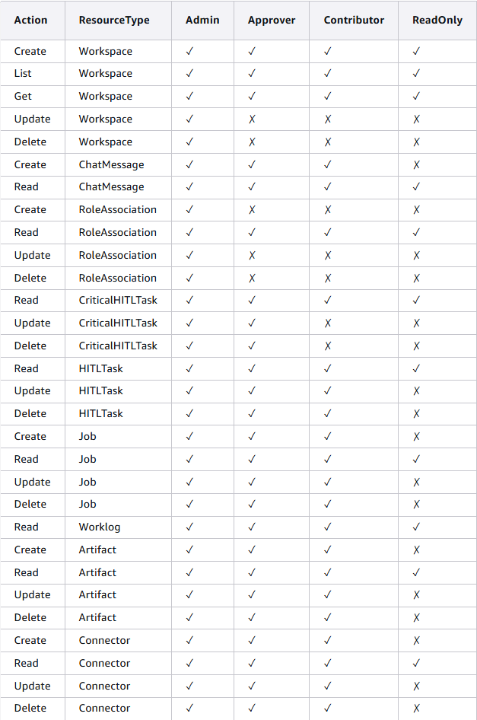

Security and Compliance
- Best Practices: AWS recommends requiring human users to use federation to access services as a best practice for managing security and identity.
- Fine-Grained Control: Federated users assume roles with specific identity-based policies. These policies define exactly what actions (e.g. transform:CreateJob) the federated user can perform on specific resources.
- Role Assumption: Federated identities assume roles to facilitate cross-account access, allowing them to manage resources across different security boundaries within an AWS Organization.

Restrictions
N/A

Permitted Regions

AWS Transform will be enables only US North Virginia us-east-1, even though it’s available in other regions.
https://docs.aws.amazon.com/transform/latest/userguide/vpc-interface-endpoints-transform-custom.html

Use Cases
Describe potential use cases. These can be references to provider use cases (such as linking to AWS documentation), or to Aegon Reference Architectures and Architecture Patterns.

Use Case One
TAI 4.0 currently functions as the primary application supporting reinsurance operations. It was recently modernized by migrating from a legacy mainframe platform to a contemporary AWS-based technology stack, delivered as a vendor application within the TA infrastructure.
As part of this transition, several ETL processes continue to run on the mainframe. The objective is to fully retire from these mainframe dependencies by migrating the COBOL-based batch of ETL jobs to the modern technology stack. The plan is to leverage AWS Transform to extract the underlying business logic and use AWS Kiro services to automatically generate modernized code based on that extracted logic.
Once converted, these jobs will be deployed and executed within the modern tech stack, ensuring improved maintainability, scalability, and alignment with the enterprise cloud strategy.
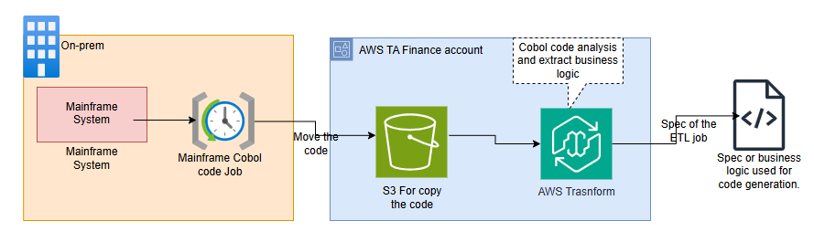
POC of Solution architecture link is DACA

Use Case Two
Short description of Use Case One.
Link to further documentation / Reference Architecture, or Architecture Pattern.

Data & Governance
Define the data that is used by each component. This includes the data's format, its location, and its security requirements. The data should be defined in a way that is consistent with the overall architecture, and that allows data to be easily shared between components.

AWS Transform components utilize a unified data architecture centered on Amazon S3, AWS CodeConnections, and the Transformation Registry to store and share modernization assets. Mainframe and VMware components primarily ingest source code (COBOL/JCL), server inventory, and network data in formats like CSV, Excel, or binary EBCDIC from customer-managed S3 buckets. .NET and SQL Server modernizations access C# source code and T-SQL schemas via secure connectors to repositories such as GitHub or Bitbucket, while storing database credentials in AWS Secrets Manager. Custom transformations use natural language prompts and markdown-based definition packages stored in the account-specific registry. Security is maintained through TLS 1.2+ encryption in transit, AWS KMS for encryption at rest (via AWS-owned or customer-managed keys), and IAM Identity Center for centralized access management. Sensitive data is further protected by workspace-level permissions and the option to opt out of AI model training for generated code and chat history.

Data Classification
Refer to the ITCF Framework and ICTF P04.01.02 Information Security Classification Standard for guidance on data classification the controls for processing, storing and transmitting data.
- Public: Can be used to transfer public files, such as marketing materials or product documentation.
- Internal: Can be used to transfer internal files, such as personal information in a defined context or operational guidelines.
- Confidential: Can be used to transfer sensitive files, such as personal information related to employees, business/marketing plans.
- Strictly Confidential: Can be used to transfer very sensitive files, such as healthcare data or government classified information, trade secrets, strategic plans.
  - PII: Can be used to transfer personally identifiable information (PII), such as names, addresses, and Social Security numbers.
  - HIPAA: Is HIPAA eligible, meaning it can be used to transfer healthcare data in compliance with the Health Insurance Portability and Accountability Act (HIPAA).
List any guidelines/restrictions for use of specific data classifications.

Data classification for AWS Transform is public: it will be used for code transformation without the usage nor access to personal data or PII.
The service doesn’t need nor require a private or PII data, but it can’t prevent the end user from exposing PII date.

Data Classification |  | Data Legal and Regulatory Classification
☐ | Strictly Confidential | ☐ | Financial Information
☐ | Confidential | ☐ | Personal Identifiable Information
☐ | Internal | ☐ | Protected Health Information
X | Public | ☐ | Payment Card Information
☐ | No Data Shared | X | No Personal Data Shared

Guardrails

Security
- Enterprise Identity Federation and Group-Based RBAC Enforcement:
To maintain secure and compliant access, AWS administrators must configure AWS Transform to use only federated identities provisioned through AWS IAM Identity Center, without creating additional users directly in IAM Identity Center. Furthermore, the creation of non‑federated users within AWS Transform must be disabled and subject to appropriate auditing controls

- Enable MFA:
All users must have MFA enabled to access AWS Transfrom

Intellectual propriete
- Opt-out of Model Training:
To prevent generated code and chat history from being used for service improvement or LLM model training, corporations must configure an AI services opt-out policy within AWS Organizations. https://docs.aws.amazon.com/organizations/latest/userguide/orgs_manage_policies_ai-opt-out.html

Network and environments
- Development environment only:
Since AWS Service A does not require access to any production‑level AWS resources, enabling it in production environments provides no operational benefit while introducing unnecessary risk.
- Access to AWS Transform from Aegon’s Network:
Access to all AWS Transform interfaces must be restricted to Aegon’s network (Cloud and onprem)

Capabilities and Product Comparison
When to use, or not use this component. Include references to alternative products if possible.

Capability Table
A table of capabilities of this component with a description and some indication of the weight of the capability used for the selection of the overall component.
Capability | Description | Requirement
Mainframe Modernization | Orchestrates the transformation of COBOL/JCL-based workloads into cloud-optimized Java. It handles analysis, business logic extraction, and monolithic decomposition. | High
Full-Stack Windows Modernization | Automates the porting of legacy .NET Framework applications to cross-platform .NET (Linux-compatible) and the migration of SQL Server to Amazon Aurora PostgreSQL. | High
Human-in-the-Loop (HITL) | Integrates mandatory approval gates for "Critical" actions, such as merging refactored code to main branches or deploying to AWS. | High
VMware Migration to EC2 | Employs AI to convert source VMware network configurations into Amazon VPC architectures and generates optimized migration wave plans for rehosting servers natively on EC2. | Medium
AWS Transform Custom | Enables natural language-driven definitions for large-scale code modernization, such as language version upgrades (e.g., Java 8 to 17) or API/library migrations across multiple repositories. | Medium
Migration Assessment | Uses AI specifically trained for AWS infrastructure to provide cost estimates, savings identification, and optimal Amazon EC2 instance recommendations,, | Medium

Component Comparison
A table of capabilities (features) in the same component-class, identifying key features, advantages and disadvantages based on the Architectural Attributes above.
Capability | <this Component> | Alternative Component | Selection Criteria

Exceptions
N/A

Related links to other architectural documents used at Aegon

https://docs.aws.amazon.com/transform/latest/userguide/what-is-service.html

